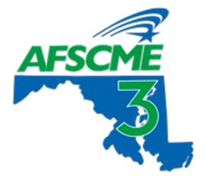

Maryland Defenders Union
Local 423, AFSCME Council 3
marylanddefendersunion@gmail.com

Marci Tarrant Johnson, President Kelli Cover, Attorney Board Member
Kalia Woods, Non-Attorney Vice-President  Edie Fortuna, Attorney Vice-President  Sally Larsen, Recording Secretary  Cheryl Hughes-Redd, Secretary-Treasurer | Elise Desiderio, Attorney Board Member  Alexis Rossetti, Attorney Board Member  Afrika Kwanna, Non-Attorney Board Member  Casi O’Neill, Non-Attorney Board Member  Naja Brown, Non-Attorney Board Member  Andrew Northrup, Trustee
February ____, 2024

To: Delegate Jazz Lewis, Chairman
Delegate Julian Ivey, Co-Chairman
Public Safety and Administration Subcommittee

RE: House of Delegates, OPD Budget Hearing Testimony
Hearing: February 14, 2024

Dear Chairman Lewis, Vice Chairman Ivey, and members of the committee:

Greetings! My name is _______________, and I am submitting this written testimony as a member of the Maryland Defenders Union, AFSCME Local 423. I have worked as an _________________ at the Office of the Public Defender in __________(office)_____________ for ____________ years.

(Discuss how underfunding affects you directly. This can be about pay, short-staffing, workload, or anything else that you feel is important to let them know. Do your best to relate it to your personal life or potential harm to the people we serve)

(End your testimony with an ask for a significant increase in budget for OPD to rectify years of underfunding)

__________________________
Signature
Job, office, etc.

